Copyright for test papers and marking guides remains with *West Australian Test Papers.*

Test papers may only be reproduced within the purchasing school according to the advertised Conditions of Sale.

Test papers should be withdrawn after use and stored securely in the school until 14th October 2021.



**SEMESTER TWO**

**MATHEMATICS**

**METHODS**

**UNITS 3 & 4**

**2021**

**SOLUTIONS**

**Calculator−free Solutions**

1. (a) 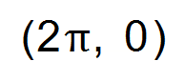

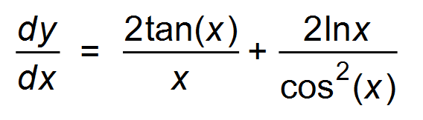 ✓

When x = 2π, *m*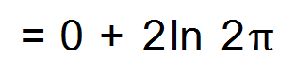 ✓

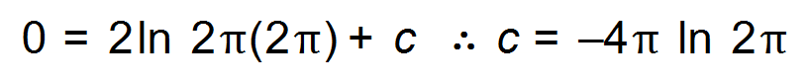

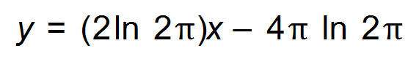 ✓

(b) 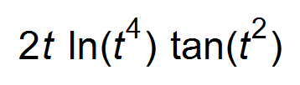 ✓✓ [5]

2. (a) 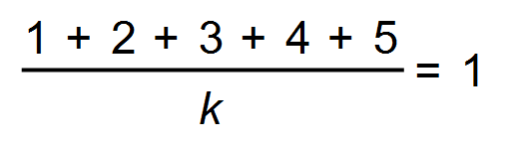

*k* = 15 ✓

(b) 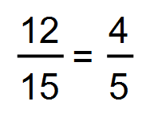 ✓

(c) 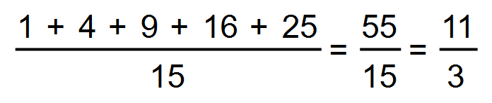 ✓

(d) (i) Expected value 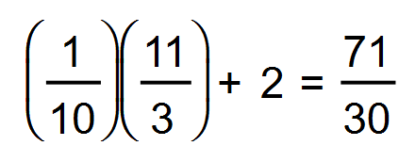 ✓

Variance of *Y*: 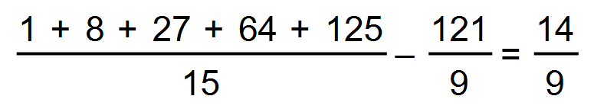

Standard deviation of *Y* = 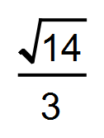 ✓

Standard deviation of *X* = 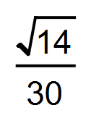 ✓

(ii) 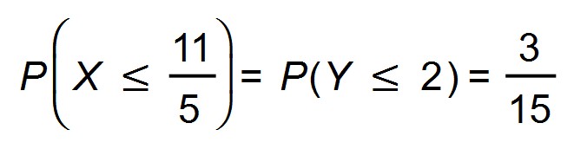 ✓✓ [8]

3. (a) 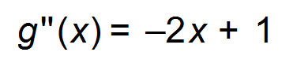 when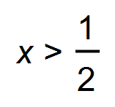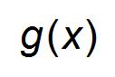is concave down ✓✓

(b) Maximum ✓

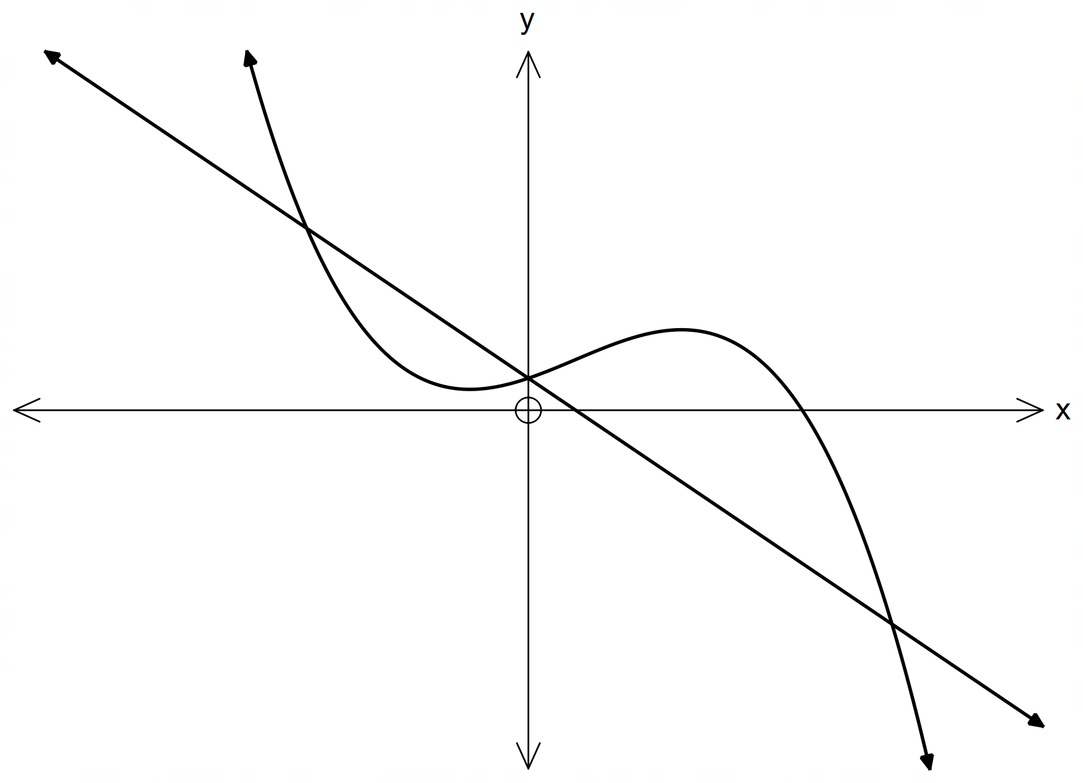 (c)

Correct point of inflection ✓

Shape showing local minimum and maximum ✓ [5]

4. (a) 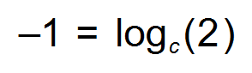

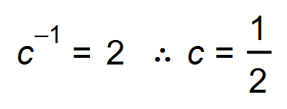 ✓

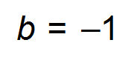 ✓

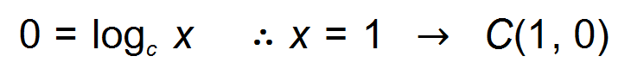

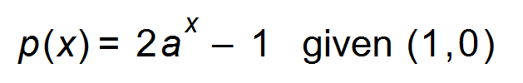

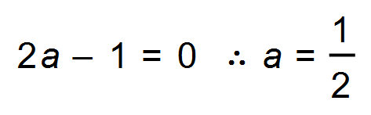 ✓

(b) 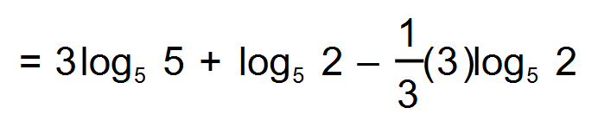 ✓

= 3 ✓

(c) 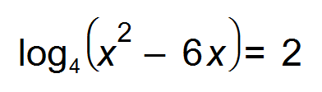 ✓

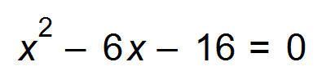

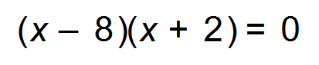

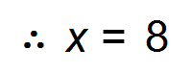 ✓ [7]

5. (a) 0.16 ✓

(b) 0.34 ✓

(c) 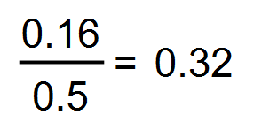 ✓✓ [4]

6. 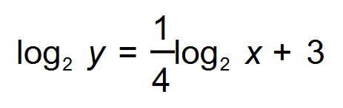

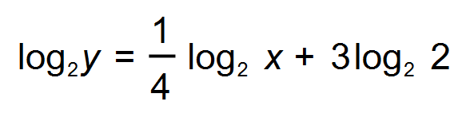 ✓

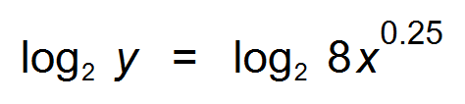

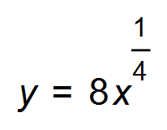 ✓

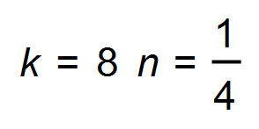 ✓ [3]

7. 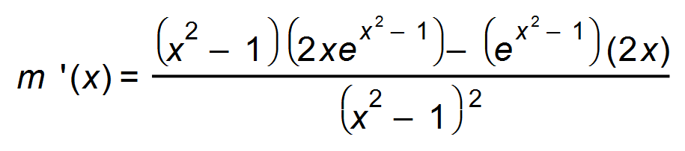 ✓

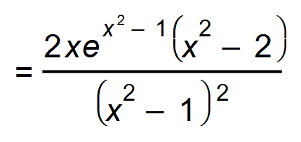

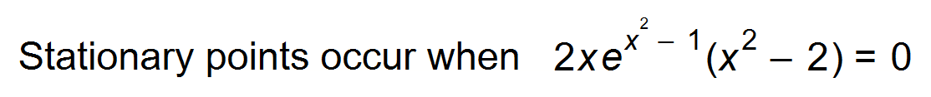 ✓

∴ 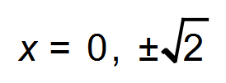 ✓

∴ 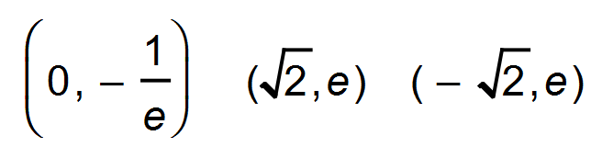 ✓ [4]

8. (a) 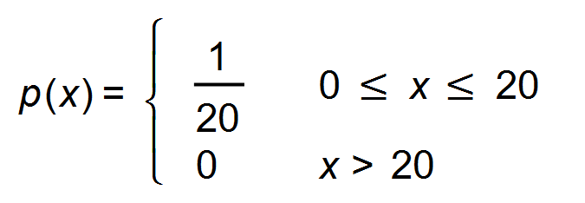 ✓

(b) 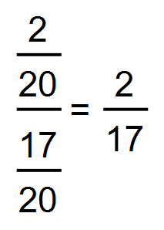 ✓✓

(c) 10 minutes ✓ [4]

9. 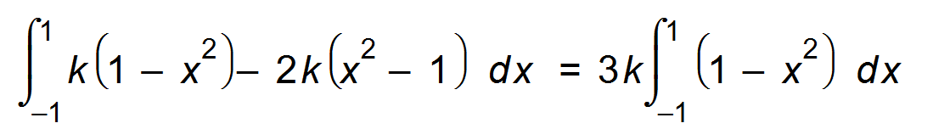 ✓

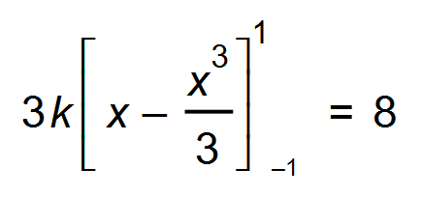 ✓

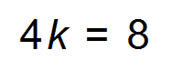

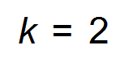 ✓ [3]

10. (a) 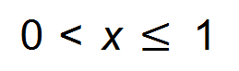 ✓✓

(b) 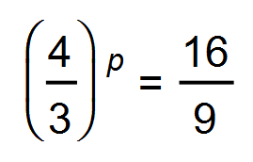 ✓

*p* = 2 ✓

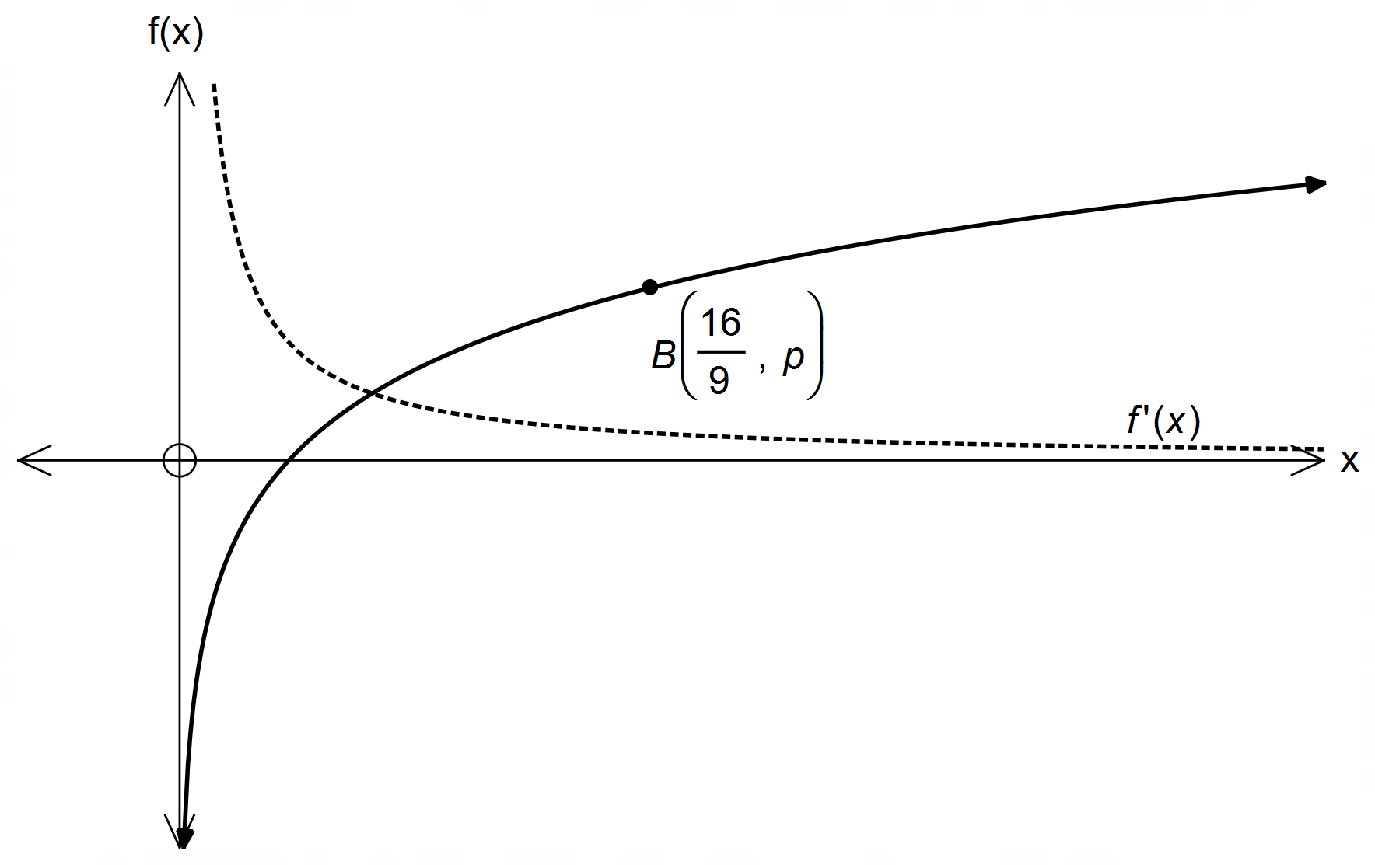(c) (i)

✓

10. (c) (ii) 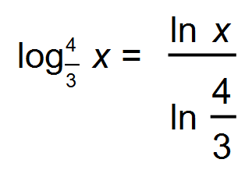

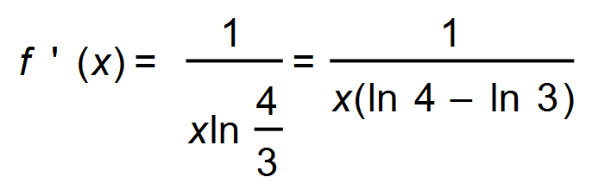 ✓✓ [7]

**Calculator−Assumed Solutions**

11. (a)  ✓

Maximum profit occurs when 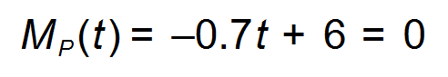

therefore *t* = 8.57 years ✓

(b) 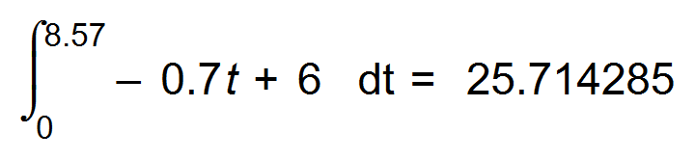 ✓

Maximum profit = $25714285-$12000000 = $13 714 285 ✓ [4]

12. (a) Discrete data; Independent events ✓

Only two outcomes: under the limit or over the limit. ✓

(b) (i) 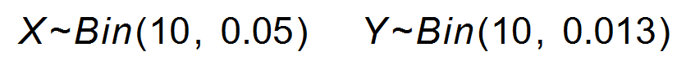 ✓

 ✓

(0.01048)+(0.07463)(0.11556)+(0.31512)(0.00685)+(0.00024)

= 0.02150 ✓

(ii) 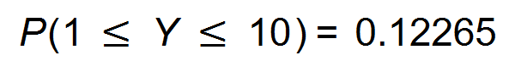 ✓

(iii) X~Bin(275, 0.05) E (X) = 13.75

∴ 13 drivers. ✓

Variance = 275 x 0.05 x 0.95 = 13.0625

Standard deviation = 3.6142 ✓

(iv) 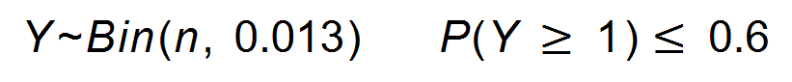

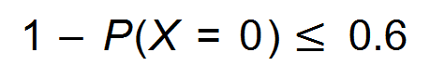 ✓

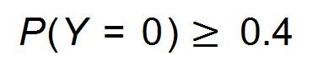

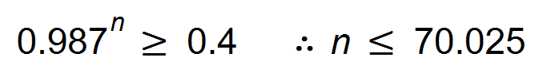 ✓

Therefore the maximum value of *n* = 70 ✓ [11]

13. Point of intersection:

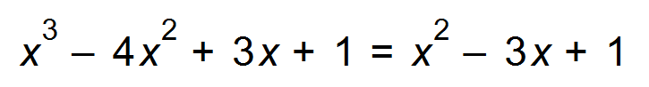

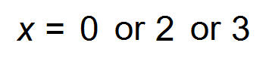

Area of shaded part:

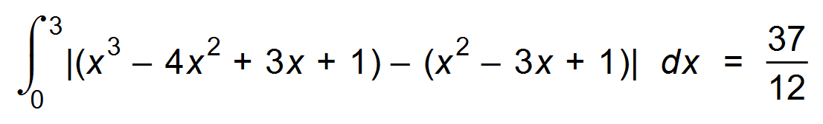 units2 ✓✓ Alternate

Shaded area under line:

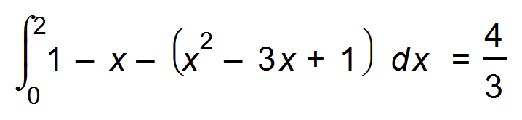 units2  ✓

Fraction: 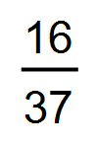 ✓ [4]

14. (a) AC = *t* – 30 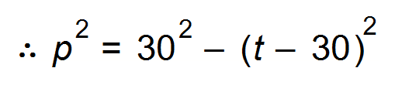 ✓

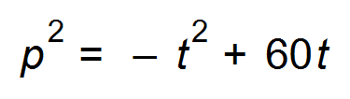 ✓

Volume of cone = 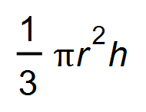

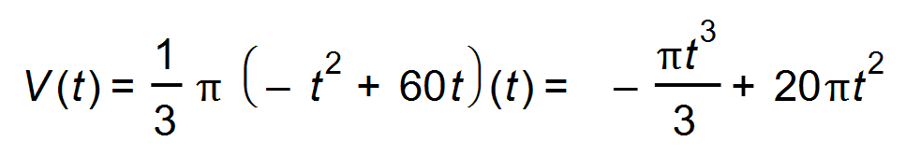 ✓

(b) 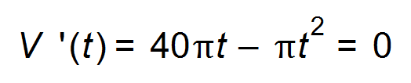 ✓

*t* = 0 or 40 ✓

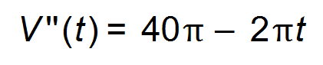

 ✓

(c) Volume of cone at *t* = 40 cm is 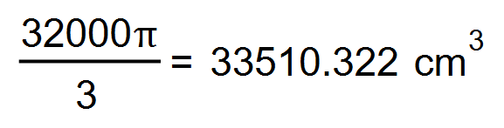 ✓

Volume of sphere = 113 097.336 cm3

Percentage = 29.63% ✓

(d) 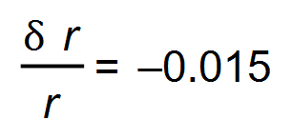 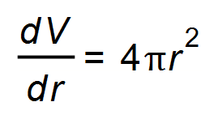 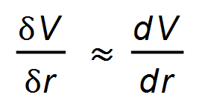

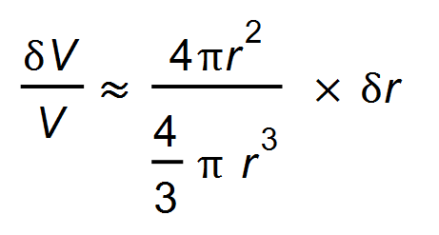 ✓

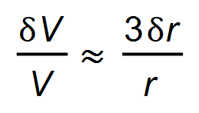

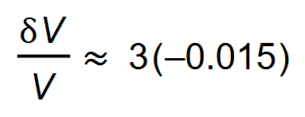 ✓

Approximately 4.5% decrease in volume. ✓ [11]

15. (a) 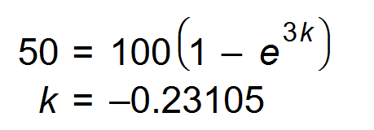 ✓

(b) Less than 5 minutes: 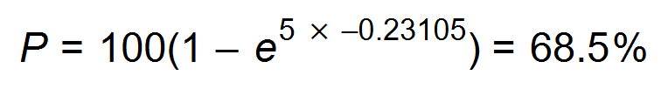 ✓

Percentage 5 minutes or longer = 31.5% ✓

(c) (i) *t* is a continuous random variable where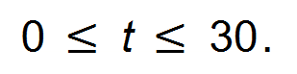

The function in the domain 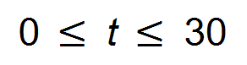is positive.

The probability at *t* = 0 is 0 and *t* = 30 is 1,

therefore is cumulative. ✓✓

(ii) 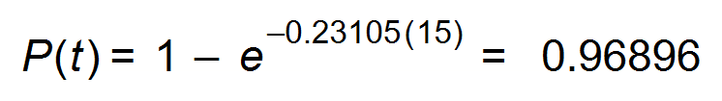 ✓

(iii) 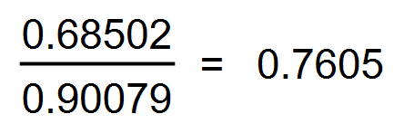 ✓✓ [8]

16. 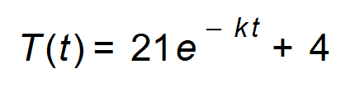

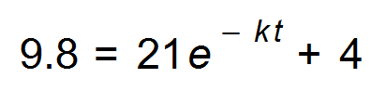 ✓

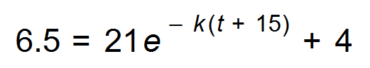 ✓

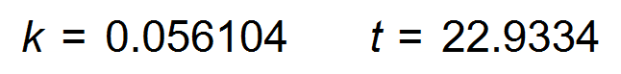 ✓

The liquid was placed in the fridge at 11:37 am ✓ [4]

17. (a) 6 year old tree is growing at a rate of 17.69 cm/year

50 year old tree is growing at a rate of 2.277 cm/year ✓

7.8 times faster ✓

(b) (i) Convenience sample: this sample may not be

representative of all the six year old trees in the plantation.

The sample is not large enough. ✓✓

(ii) Stratified sample where a number of trees from each

area according to the size of the area are chosen at random.

Or

Systematic and Array sample: Every *n*th tree starting

at a randomly assigned tree as one walks down each row.✓✓

(c) (i) 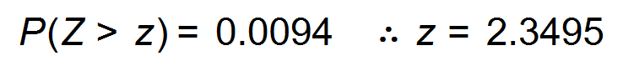 ✓

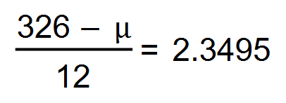 ✓

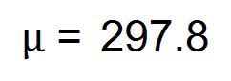cm ✓

(ii) According to the model, the height of a six year old tree

is 297.8 cm and the mean of the sample is the same,

therefore the model is suitable. ✓

(iii) 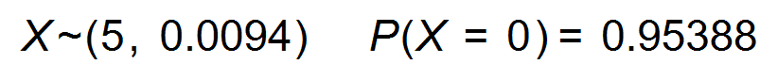 ✓

(d) 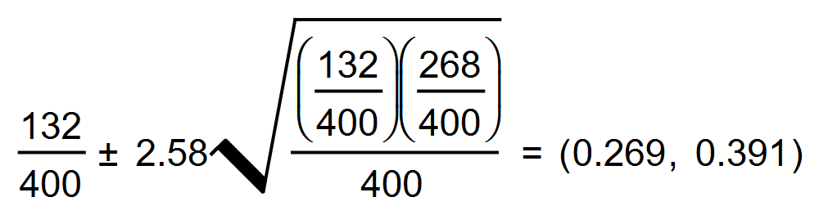 ✓✓

With a 99% confidence level, between 26.9% and 39.1% of the

mature trees can be used for luxury furniture. ✓ [14]

18. Over - estimate = 0.2(0.127+0.172+0.184+0.184+0.181) = 0.1696 ✓

Under - estimate = 0.2(0+0.127+0.172+0.181+0.173) = 0.1306 ✓

Average = 0.1501 units2 ✓ [3]

19. (a) (i) *n* > 30

*np* = 300 x 0.12 = 36 *npq* = 300 x 0.12 x 0.88 = 31.68

*np* > 10 *npq* > 10 therefore

a normal distribution can apply. ✓✓

(ii) 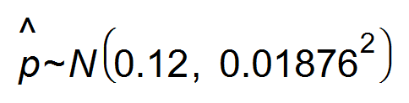 ✓✓

(iii) 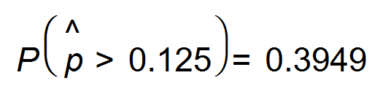 ✓

(iv) 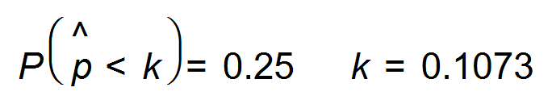 ✓

10.7% ✓

(b) (i) 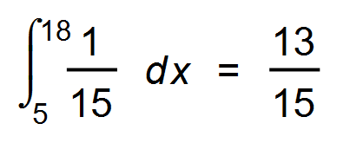 ✓

(ii) Expected waiting time= 12.5 days ✓

Normal distribution 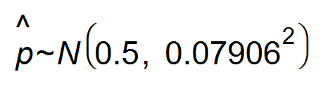 ✓✓

(iii) 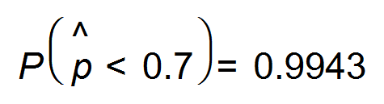 ✓ [12]

20. (a) 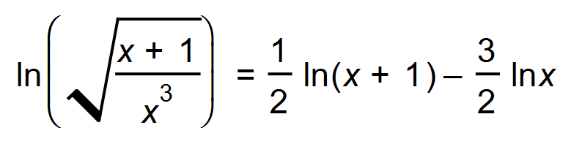 ✓

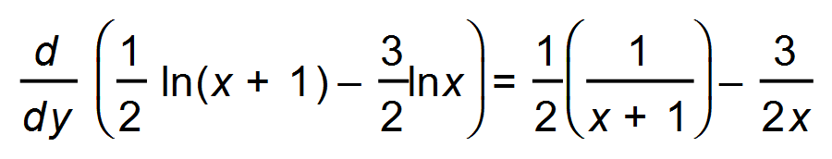 ✓✓

= 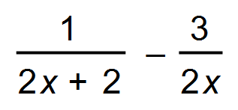

(b) (i) 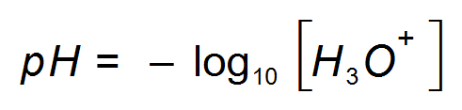

Hydronium ions range from

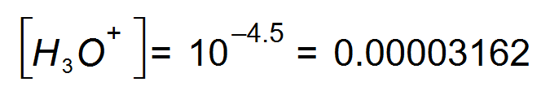 moles per litre ✓

to

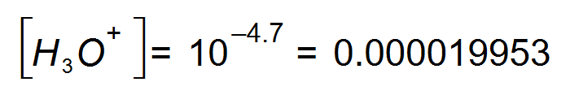moles per litre ✓

(ii) 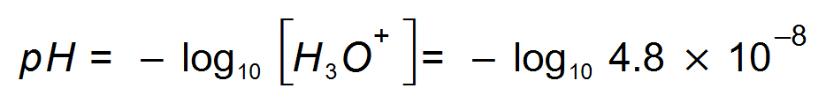 ✓

*pH* = 7.32 therefore it is not acidic. ✓ [7]

21. (a) 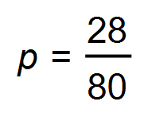 ✓

(b) (i) (0.2455, 0.4545) ✓✓

(ii) ME=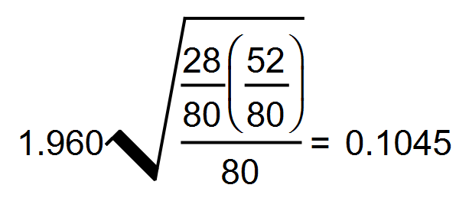 ✓

(iii) 95% the width is 0.209

99% the width is 0.2747 ✓

0.209*x* = 0.2747

*x* = 1.3144 ✓

Therefore an increase of 31.45%

(c) 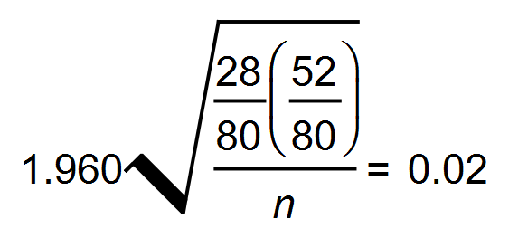 ✓

*n* = 2184.9 ✓

Therefore sample size of 2185 ✓

(d) 0.95 x 40 = 38

∴ Approximately 38 would contain the true proportion ✓ [10]

22. (a) 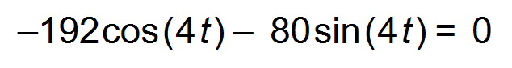

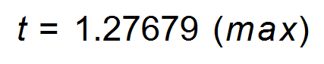 ✓

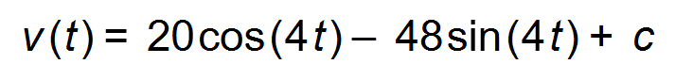

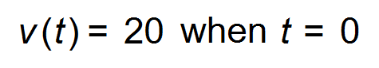 therefore c = 0 ✓

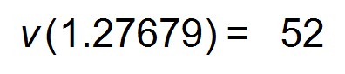units/sec ✓

(b) 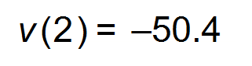units/sec ✓

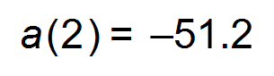 units/sec2 ✓

The velocity and the acceleration are both negative,

therefore the particle is moving faster to the left.

∴ Increasing speed ✓

(c) 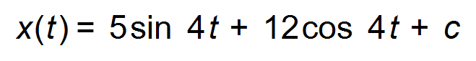

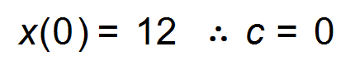 ✓

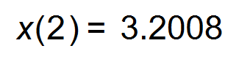units ✓

(d) 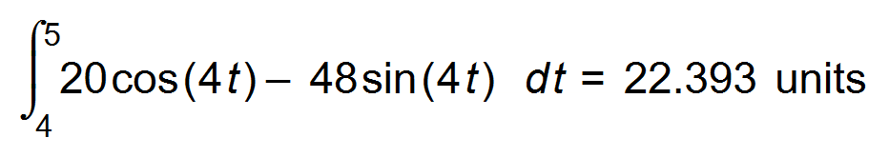 ✓✓

(e) 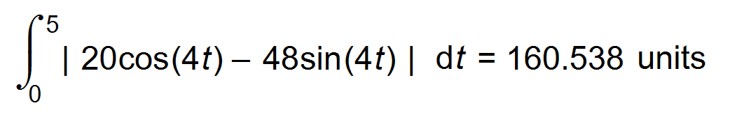 ✓✓ [12]

End of Questions